27.65: a)
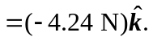
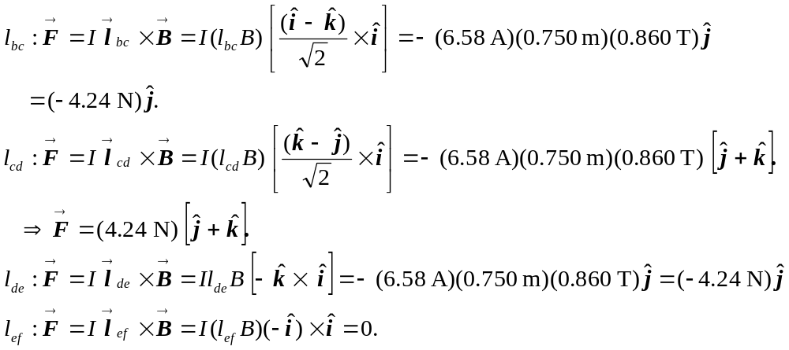
b) Summing all the forces in part (a) we have 